**Mlab: The Outstanding Leader in the Mining Consumables Field**

**Company Introduction**

Mlab is a company specializing in consumables for mining laboratories and mines. With a deep - understanding of the industry and professional R & D and supply capabilities, we are committed to providing high - quality and comprehensive consumable products and solutions to global mining - related customers. From geological exploration to mine exploitation and then to laboratory analysis, our products run through all links of the mining process, helping customers improve work efficiency and ensure operational safety and accuracy.

**Product Display**

**Core Storage and Transportation**

In the fields of geological exploration and mining, the proper preservation and transportation of core samples are of great importance. Our core tray, with its sturdy materials and reasonable structural design, provides a stable storage space for core samples. Whether on - site in field exploration or in laboratory storage, it can effectively protect core samples from damage and ensure the accuracy of subsequent analysis and research.

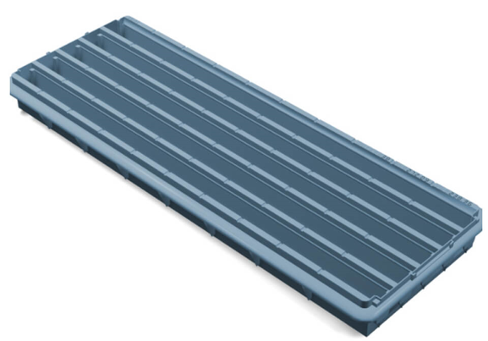

**Treasures of Fire Assay**

**Crucible**

For the fire assay process, our crucible is an essential key instrument. It can withstand extremely high temperatures, stably hold various raw materials during the assaying process, and facilitate the smooth progress of chemical reactions. Its excellent high - temperature resistance and chemical stability make it a trusted choice for assayers, providing a solid guarantee for the extraction of precious metals.

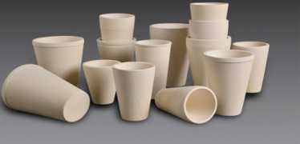

**Cupel - Mable**

The Mable cupel plays a unique role in the cupellation process of fire assay. It precisely meets specific process requirements and can efficiently complete fine operations such as metal purification. Its unique materials and design ensure excellent performance in complex assaying processes, being favored by professionals who pursue high - quality assaying results.

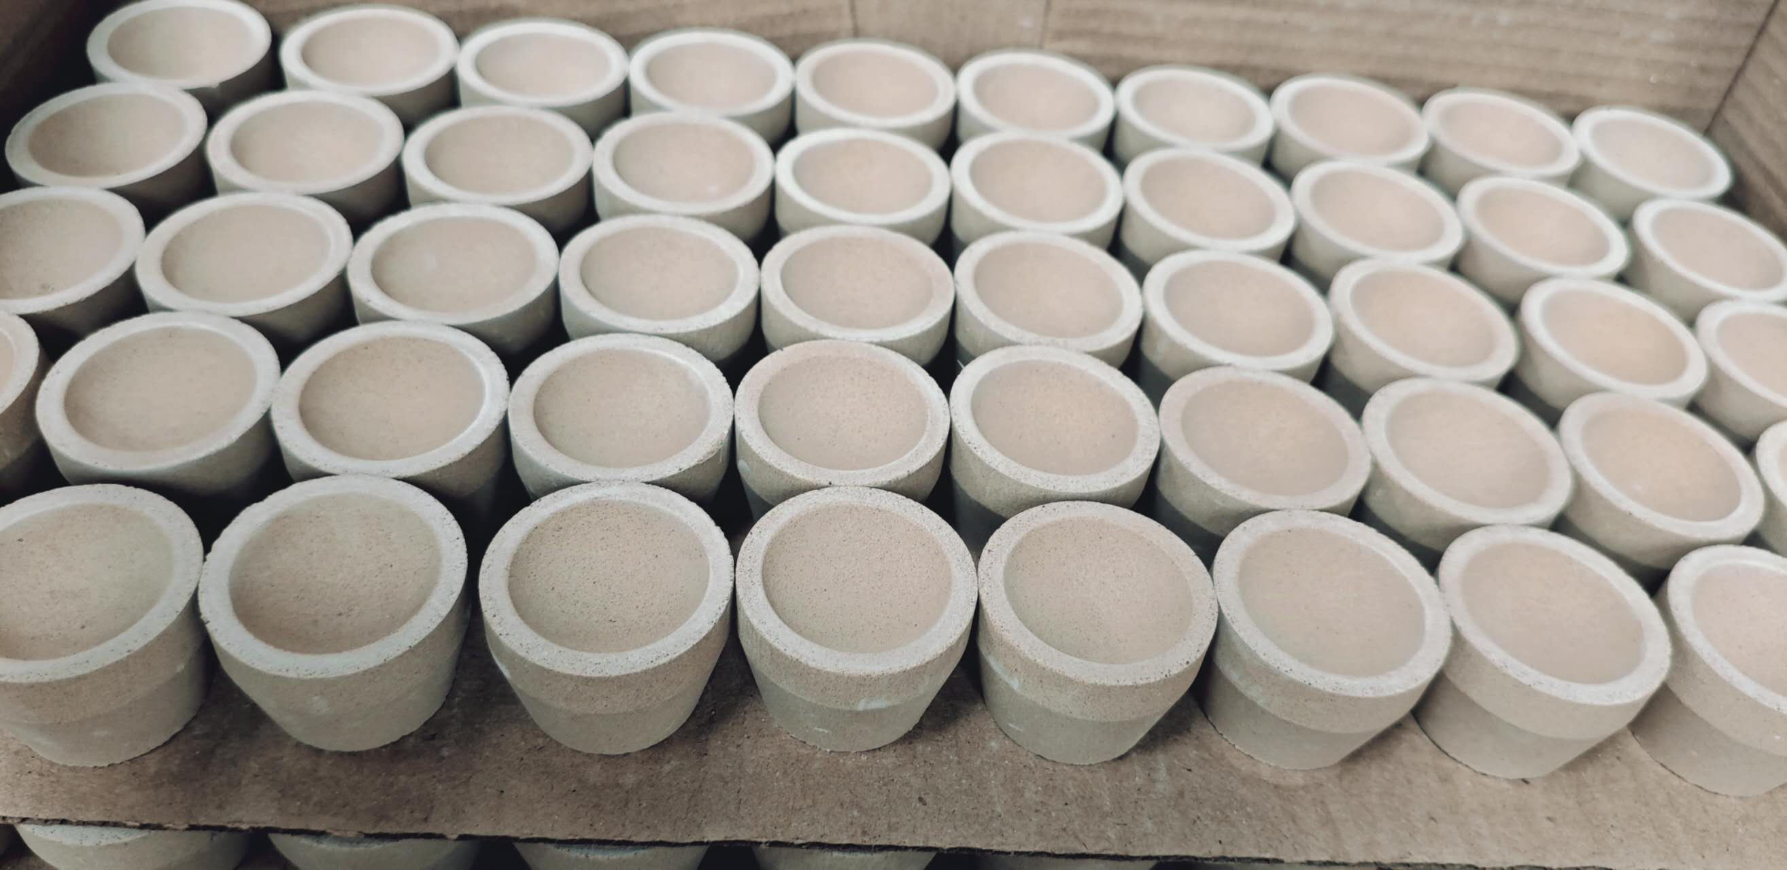

**Safety Protection and Packaging**

**Gloves**

Safety is the foundation of all work. Our gloves are made of high - quality materials and have excellent wear - resistance, heat - insulation, and chemical - corrosion resistance. Whether in a high - temperature assaying operation environment or various other labor - operation scenarios, they can provide all - round protection for your hands, allowing you to work without worries.

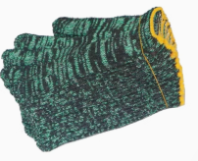

**Stretch Film**

In the transportation and storage of goods, our stretch film shows powerful functions. It can tightly wrap goods, providing a stable fixing effect and preventing goods from scattering and shifting during handling. Meanwhile, its good dust - proof and moisture - proof properties can also effectively protect the quality of goods, being a reliable assistant in the logistics and warehousing links.

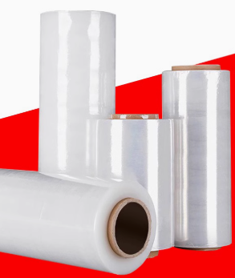

**Company Vision**

Mlab harbors the grand vision of becoming the most influential enterprise in the global mining consumables field. We are determined to keep innovating, and continuously launch higher - quality, more efficient, and more environmentally - friendly consumable products for mining laboratories and mines with cutting - edge technologies and exquisite craftsmanship.

In terms of quality, we pursue the ultimate and strictly control every production link to ensure that products meet the highest standards and provide customers with reliable guarantees worthy of trust. In terms of service, we are committed to building a professional, efficient, and attentive team to provide customers with all - round and personalized services to meet the unique needs of different customers.

We are eager to work hand in hand with global mining counterparts to jointly promote the sustainable development of the mining industry. By providing excellent consumable products and solutions, we help mining enterprises enhance their competitiveness and achieve positive contributions to the environment and society while creating economic value. Mlab will always adhere to its original aspiration, constantly surpass itself, and forge ahead bravely towards becoming a benchmark enterprise in the mining consumables field.